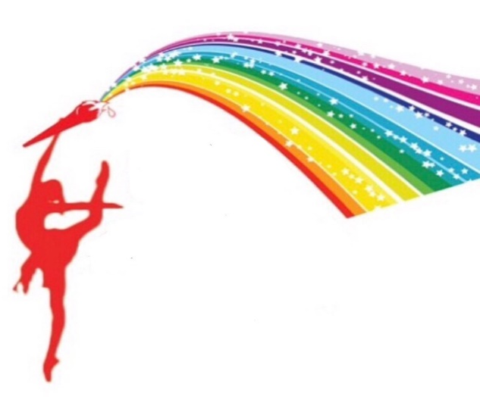
A Brush of Art

Paint Party Application and Payment Agreement
Name: ___________________________________________ (of person booking the party)
Guest of Honor Name: ____________________________________________ Age: ___ Gender: ___
Location for the party/ Address: __________________________________________________________
Phone #: ___________________________________ Alt. Phone #: ____________________________
Email: ______________________________________ (Both emails and texts will be our primary method of communication)
-------------------------------------------------------------------------------------------------------------------------------------
Check the type of PAINT party you’re are booking below
____Kiddie Creativity Party $250
- $30 nonrefundable deposit/ set up fee
- Up to 10 guests
- Includes all paint supplies: easels, canvases, brushes, smocks, paint, pallets, napkins and cups of water.
- Each additional guest $25
- Up to 2 hours of instruction
- FREE gift for guest of honor or host
UPGRADE MY PACKAGE TO INCLUDE PIZZA, SNACKS & DRINKS (additional $5 per guest)
plates and napkins included. Circle YES or NO

____Adult Artistry Party $300
- $30 nonrefundable deposit/ set up fee
- Up to 10 guests
- Includes all paint supplies: easels, canvases, brushes, smocks, paint, pallets, napkins and cups of water.
- Each additional guest $30
- Up to 2 hours of instruction
- FREE gift for guest of honor or host
UPGRADE MY PACKAGE TO INCLUDE WINE & DESERT (additional $6 per guest)
Plates and cups included. Circle YES or NO

Total number of Participants must be confirmed 72hrs in advance
The total cost of the party will not be changed if guests do not show up. NO EXCEPTIONS!!
Tables and chairs not supplied or included in the cost.
***BALANCE DUE UPON START OF THE PARTY.***

